

Jméno autora: Mgr. Mária Filipová  
Datum vytvoření: 15. 8. 2013  
Ročník: 1. – 4. ročník

Číslo DUMu: VY_32_INOVACE_18_AJ_CM

Vzdělávací oblast: Jazyk a jazyková komunikace

Vzdělávací obor: Anglický jazyk

Tematický okruh: konverzační témata pro studenty různých oborů

Téma: Body parts – verbs - test

Klíčová slova: body parts, verbs,

Metodický list/anotace: Výukový materiál slouží ke kontrole znalostí slovní zásoby, se kterou byli studenti seznámeni.Jedná se o jednoduchý test, kdy studenti doplňují správne sloveso do věty tak, aby dávala smysl.

V rámci opakování taky správně pojmenují jednotlivé části lidského těla.

***Our body***

***Try to name as many parts as possible.***

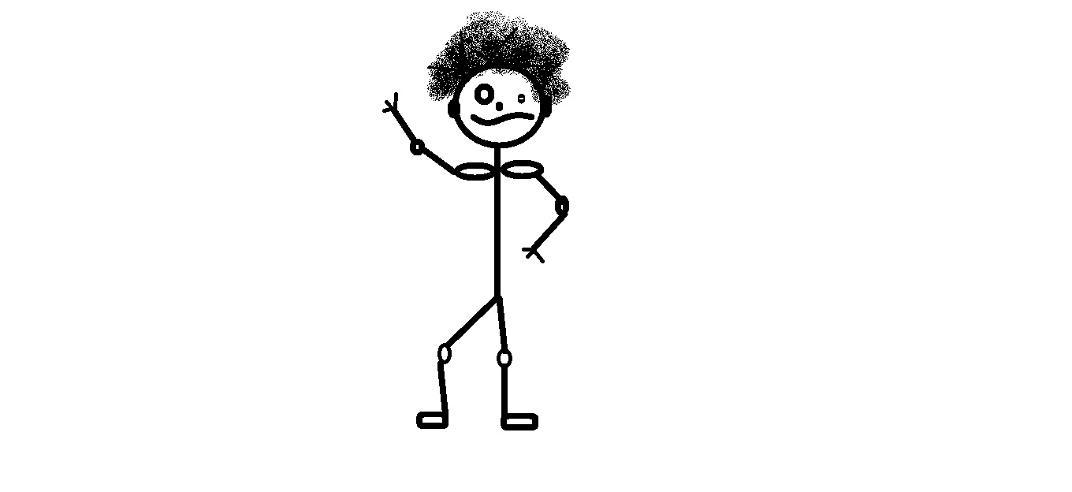

If you can write more with Czech translations:

***Some English words for body parts can be used as verbs.***

***Use the correct form of the verb to complete sentences.***

I don´t have enough money to pay, could you ________the bill and I will pay next time.

He just cannot___________the way she pretends to know so much more than he does.

The police officer wants you to___________the two men you think commited the crime.

The boss will ________the work, we will just follow him.

The soldier wanted to _________the enemy.

People in crowds sometimes aggressively __________their way.

Many people intend to _ _________the political candidates who promise to solve their social problems.

When you finish this work, you must __________it in to the teacher.

She told him she wouldn´t __________with him since she didn´t love him.

They have quite a burden to _______ since nobody volunteered to help them.

***Answers***

I don´t have enough money to pay, could you ***foot*** the bill and I will pay next time.

He just cannot ***stomach*** the way she pretends to know so much more than he does.

The police officer wants you to ***finger*** the two men you think commited the crime.

The boss will ***head*** the work, we will just follow him.

The soldier wanted to ***knee*** the enemy.

People in crowds sometimes aggressively ***elbow*** their way.

Many people intend to ***back*** the political candidates who promise to solve

their social problems.

When you finish this work, you must ***hand*** t in to the teacher.

She told him she wouldn´t ***neck*** with him since she didn´t love him.

They have quite a burden to ***shoulder*** since nobody volunteered to help them.

