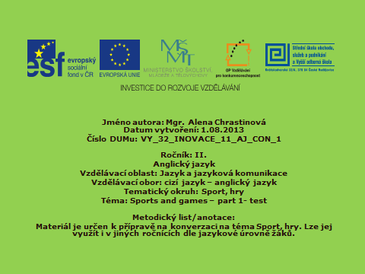



Test navazuje na materiál **: VY_32_INOVACE_09_AJ_CON_1**

Žáci vyplňují test a následně provedou kontrolu na základě řešení promítaného na tabuli.

Sports and games – part 1- test

**1. Fill in the blanks**

|  |  |  |  |  |  |
| --- | --- | --- | --- | --- | --- |
| pohyb | účinek | přínos | tělo | duše | vůle |
|  |  |  |  |  |  |
| vytrvalost | spoluhráč | protihráč | soutěž | sport. disciplína | výkon |
|  |  |  |  |  |  |
| sport. zařízení | vybavení | fanoušek | roztleskávačka | zápas | halové sporty |
|  |  |  |  |  |  |
| bojové sporty | potápění | prsa (styl) | tenisky | mikina | tepláky |
|  |  |  |  |  |  |
| šerm | vzpírání | box | běžecká dráha | sjezdovka | golf. hřiště |
|  |  |  |  |  |  |
| kladina | soustředěný | prohrát | zvýšit | zlepšit | spolupracovat |
|  |  |  |  |  |  |

36 points

**2. Write the names of the places where the following sports and games are practised.**

* The players use rackets and a small ball which they hit over a net. …………………………………………………………..
* The game is played by two teams of eleven players who try to kick a round ball into a goal. …………………………………………………………..
* The game is played outdoors on a large area of grass. The players need a special stick to hit a small hard ball into small holes. …………………………………………………………..
* If you want to do this sport you need a hill, some snow and two pieces of long, narrow and smooth things attached to your feet. …………………………………………………………..
* This place is used when cars and motorcycles compete.

…………………………………………………………..

* The game is played on special cold surface by two teams. The players need curved sticks and try to hit a special hard round thing into a goal. …………………………………………………………...
* A large room or a building equipped for doing physical exercise. …………………………………………………………...

14 points

ALTOGETHER: 50 points

MY SCORE: ……………..

Sports and games – part 1- test **SOLUTION**

1. **Fill in the blanks**

|  |  |  |  |  |  |  |
| --- | --- | --- | --- | --- | --- | --- |
| pohyb | | účinek | přínos | tělo | duše | vůle |
| movement | | effect | benefit | body | soul | will |
| vytrvalost | | spoluhráč | protihráč | soutěž | sport. disciplína | výkon |
| persistance | team-mate | opponent | competition | event | performance |
| sport. zařízení | vybavení | fanoušek | roztleskávačka | zápas | halové sporty |
| sports facilities | equipment | fan | cheerleader | match | indoor sports |
| bojové sporty | potápění | prsa (styl) | tenisky | mikina | tepláky |
| combat sports | diving | breaststroke | sneakers | sweatshirt | trackpants/  tracksuit bottoms |
| šerm | vzpírání | box | běžecká dráha | sjezdovka | golf. hřiště |
| fencing | weightlifting | boxing | running track | ski slope | golf course |
| kladina | soustředěný | prohrát | zvýšit | zlepšit | spolupracovat |
| beam | concentrated | lose | increase | improve | cooperate |

36 points

**2. Write the names of the places where the following sports and games are practised.**

* The players use rackets and a small ball which they hit over a net. TENNIS COURT
* The game is played by two teams of eleven players who try to kick a round ball into a goal. FOOTBALL FIELD
* The game is played outdoors on a large area of grass. The players need a special stick to hit a small hard ball into small holes. GOLF COURSE
* If you want to do this sport you need a hill, some snow and two pieces of long, narrow and smooth things attached to your feet. SKI SLOPE
* This place is used when cars and motorcycles compete.

RACING CIRCUIT

* The game is played on special cold surface by two teams. The players need curved sticks and try to hit a special hard round thing into a goal. ICE RING
* A large room or a building equipped for doing physical exercise. GYM

14 points

ALTOGETHER: 50 points

MY SCORE: ……………..

