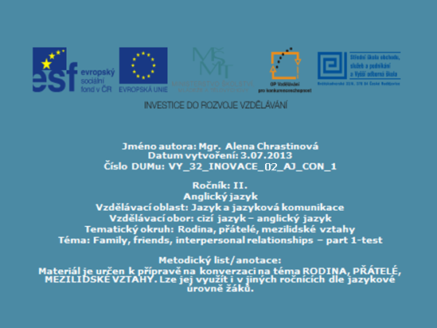

C:\Users\Lenovo\AppData\Local\Microsoft\Windows\Temporary Internet Files\Content.IE5\G1IXE2OY\MC900354228[1].wmf

Test navazuje na materiál **: VY_32_INOVACE_01_AJ_CON_1**

Žáci vyplňují test a následně provedou kontrolu na základě řešení promítaného na tabuli.

Family, friends, interpersonal relationships - part 1-test

**1. Fill in the blanks**

|  |  |  |  |  |  |
| --- | --- | --- | --- | --- | --- |
| ochrana | emoc. podpora | dospělí | prarodiče | příbuzní | manželé |
|  |  |  |  |  |  |
| sňatek | svatba | rozvod | narození  dítěte | smrt | pohřeb |
|  |  |  |  |  |  |
| bezdětný | svobodný | vdaná | rozvedený | vdova | důchod |
|  |  |  |  |  |  |
| líbánky | hádka | starý mládenec | sirotek | dvojčata | sestřenka |
|  |  |  |  |  |  |
| nevl. otec | strýc | teta | neteř | synovec | sourozenci |
|  |  |  |  |  |  |
| milenka | milenci | nevěsta | porodní asistentka | soused | kolega |
|  |  |  |  |  |  |

36 points

**2. Translate into English**

* Jsem po mamince. ……………………………………………………
* Žiji sám/sama. ……………………………………………………
* Rodiče žijí odděleně. ……………………………………………………
* Udržuji s nimi kontakt. ……………………………………………………
* Vycházím s nimi dobře. ……………………………………………………
* Občas se hádáme. ……………………………………………………
* Vždycky mi vynadají. ……………………………………………………
* Pak se usmíříme. ……………………………………………………
* Nikdy mě nebili. ……………………………………………………

18 points

**3. Complete the sentences with suitable words beginning as indicated:**

* She´s an only child, she gets everything she likes, so she´s terribly ……………………….. (S)
* She´s a real beauty. He ……………………….. (F) with her at first sight.
* They had an argument every other day. Then he found someone else and ………………………..(B) with her.
* The secretary is not married to him but she ……………………….. (S)

with him. (žije s ním na hromádce)

* She´s not so fat. She´s ……………………….. (P/E)
* The man was neither ill nor killed. He couldn´t overcome his problems and commited ………………………..(S)

6 points

ALTOGETHER: 60 points

MY SCORE: ……………..

Family, friends,interpersonal relationships - part 1- test **SOLUTION**

**1. Fill in the blanks**

|  |  |  |  |  |  |
| --- | --- | --- | --- | --- | --- |
| ochrana | emoc. podpora | dospělí | prarodiče | příbuzní | manželé |
| protection | emotional support | adults | grandparents | relatives | couple |
| sňatek | svatba | rozvod | narození  dítěte | smrt | pohřeb |
| marriage | wedding | divorce | babybirth | death | funeral |
| bezdětný | svobodný | vdaná | rozvedený | vdova | důchod |
| childless | single | married | divorced | widow | retirement |
| líbánky | hádka | starý mládenec | sirotek | dvojčata | sestřenka |
| honeymoon | argument | bachelor | orphan | twins | cousin |
| nevl. otec | strýc | teta | neteř | synovec | sourozenci |
| step-father | uncle | aunt | niece | nephew | siblings |
| milenka | milenci | nevěsta | porodní asistentka | soused | kolega |
| mistress | lovers | bride | midwife | neighbour | colleague |

36 points

**2. Translate into English**

* Jsem po mamince. I take after my Mum.
* Žiji sám/sama. I live on my own.
* Rodiče žijí odděleně. My parents are separated.
* Udržuji s nimi kontakt. I keep in touch with them.
* Vycházím s nimi dobře. I get on well with them.
* Občas se hádáme. We argue at times.
* Vždycky mi vynadají. They always tell me off.
* Pak se usmíříme. Then we make up.
* Nikdy mě nebili. They´ve never beaten me.

18 points

**3. Complete the sentences with suitable words.**

* She´s an only child, she gets everything she likes, so she´s terribly SPOILT.
* She´s a real beauty. He FELL IN LOVE with her at first sight.
* They had an argument every other day. Then he found someone else and BROKE UP with her.
* The secretary is not married to him but she SHACKS UP with him. (žije s ním na hromádce)
* She´s not so fat. She´s PREGNANT/EXPECTING.
* The man was neither ill nor killed. He couldn´t overcome his problems and commited SUICIDE.

6 points

ALTOGETHER: 60 points



